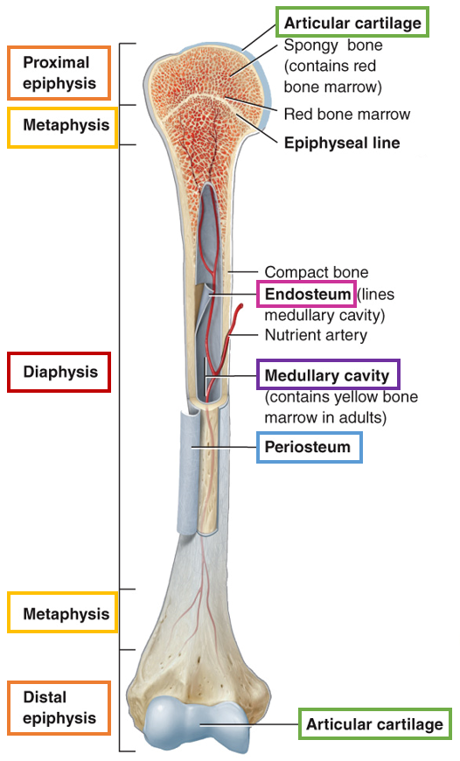**UNIT 2 STUDY GUIDE  
  
CH 6: Introduction to Bones***— types of bones:*[1] **long:** consist of a shaft and a variable number of extremities or epiphyses (ends)  
 ex: femur, tibia, fibula, humerus   
[2] **short:** somewhat cubed shaped; nearly equal in length and width  
 ex: carpal and tarsal bones  
[3] **flat**: generally thin and composed of two nearly parallel plates of compact bone tissue enclosing a layer of spongy bone tissue  
 ex: cranial bones, sternum, ribs   
[4] **irregular:** have complex shapes and cannot be grouped into any other category  
 ex: vertebrae, hip bones, certain facial bones, calcaneus  
[5] **sesamoid:** develop in certain tendons where there is considerable friction, tension, and physical stretch  
 ex: patella   
[6] **sutural:** small bones located in sutures (joints) between certain cranial bones  
   
*— bone structure:*[1] **diaphysis:** bone shaft/body; makes up the long,   
cylindrical portion of the bone  
[2] **epiphysis:** proximal and distal ends of the bone   
[3] **metaphysis:** regions between the diaphysis and   
epiphyses   
🡪 in a growing bone, each metaphysis contains an   
epiphyseal growth plate = layer of hyaline cartilage that allows  
the diaphysis of the bone to grow in length  
🡪 when a bone stops growing, the hyaline cartilage is   
replaced with actual bone  
[4] **articular cartilage:** thin layer of hyaline cartilage covering  
the part of the bone that forms a joint (articulation)  
[5] **periosteum:** tough connective tissue sheath that   
surrounds the bone surface   
[6] **medullary cavity:** hollow cylindrical space containing   
fatty yellow bone marrow  
[7] **endosteum:** thin membrane that lines the medullary cavity

*— cell types:*[1] osteoprogenitor cells: stem cells   
[2] osteoblasts: bone-BUILIDNG cells = synthesize collagen  
[3] osteocytes: mature bone cells = help maintain bone homeostasis   
-------------------------------------------------  
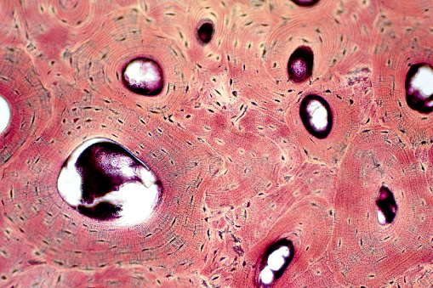[4] osteoclasts: bone-degrading cells = release lysosomal enzymes and acids that digest bone tissue in a process called bone resorption

**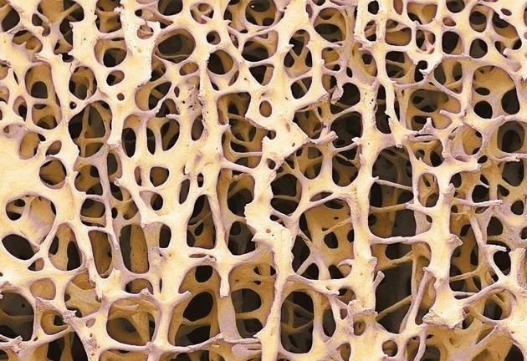***—* ***compact bone:***location: found beneath the periosteum of all bone   
function: helps the bone resist the stress produced by weight and movement  
structure: composed of repeating structural units called **osteons**   
*—* ***spongy bone:***location: in the interior of the bone, protected by a   
covering of compact bone  
function: storage of bone marrow  
structure: consists of lamellae that arranged in   
irregular pattern of thin columns called **trabeculae**

**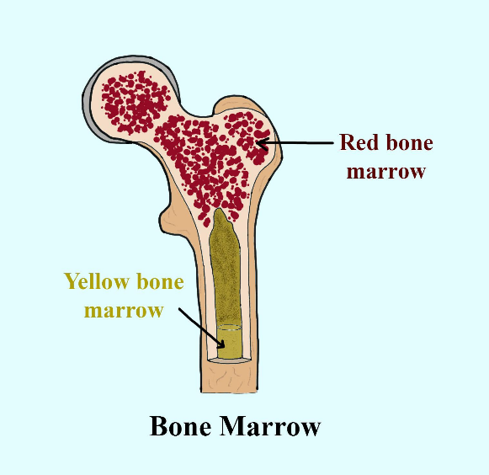***—* ***red bone marrow:*** primary source of new blood cells🡪 located between the trabeculae of certain bones   
 (ex. ribs, sternum, long bones)  
*—* ***yellow bone marrow:*** comprised of adipocytes🡪 located in diaphysis of long bones   
 (ex. femur, tibia, and humerus)

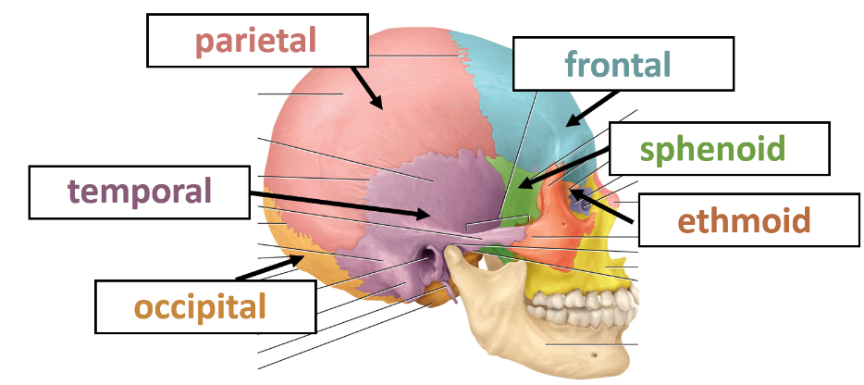**CH 7: Axial Skeleton   
  
axial skeleton:** consists of the bones that lie around the longitudinal axis of the body   
  
*—* **cranial bones:** those that form the cranial cavity

**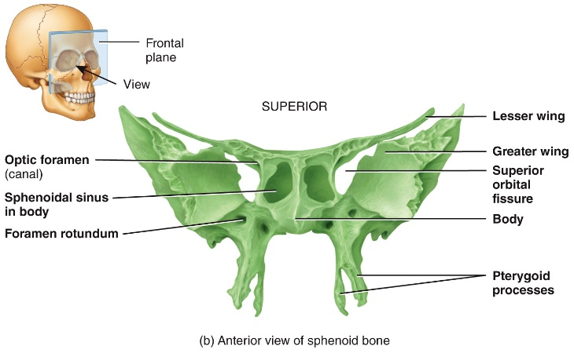***—* **sphenoid:** “keystone of the cranial floor”🡪 houses optic foramen   
 superior orbital fissure   
 inferior orbital fissure

*—* **ethmoid:** forms part of the cranial floor,   
orbits, nasal septum, and most superior structure of the nasal cavity

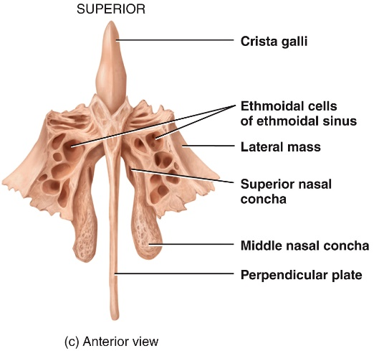**cribriform plate:** forms the roof of the nasal cavity  
🡪 contains the olfactory foramina through which the olfactory  
nerves pass  
**crista galli:** projects superiorly from the cribriform plate and serves  
as a point of attachment for the falx cerebri = membrane that   
separates the 2 hemispheres of the brain  
**perpendicular plate:** projects inferiorly from the cribriform plate   
and forms the superior portion of the nasal septum  
**lateral masses:**   
🡪 contains ethmoid sinus   
🡪 contains superior nasal concha and middle nasal concha

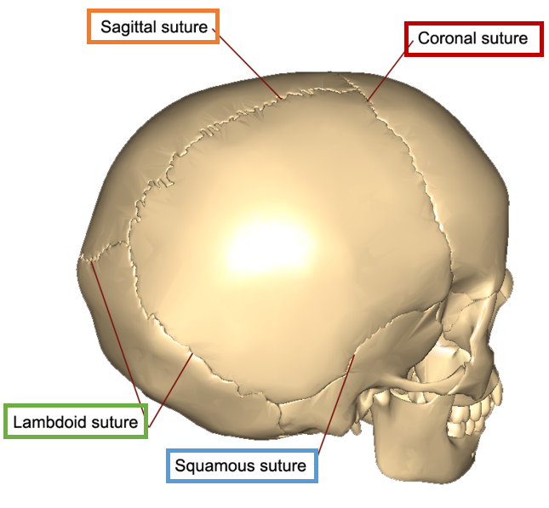*—* **cranial sutures:** immovable joints (in adults)   
that hold most of the skull bones together  
[1] coronal suture [2] sagittal suture   
[3] lamboid [4] squamous   
*—* **fontanels**: areas where unossified mesenchyme   
develop into dense connective tissue of the skull

*—* **facial bones:** form the face

**maxillae (2):** form the upper jaw   
**mandible:** form the lower jaw   
**inferior nasal concha (2):** increase the surface   
area of the nasal cavity and help swirl and filter air   
before it passes into the lungs  
**nasal bones (2):** form the bridge of the nose

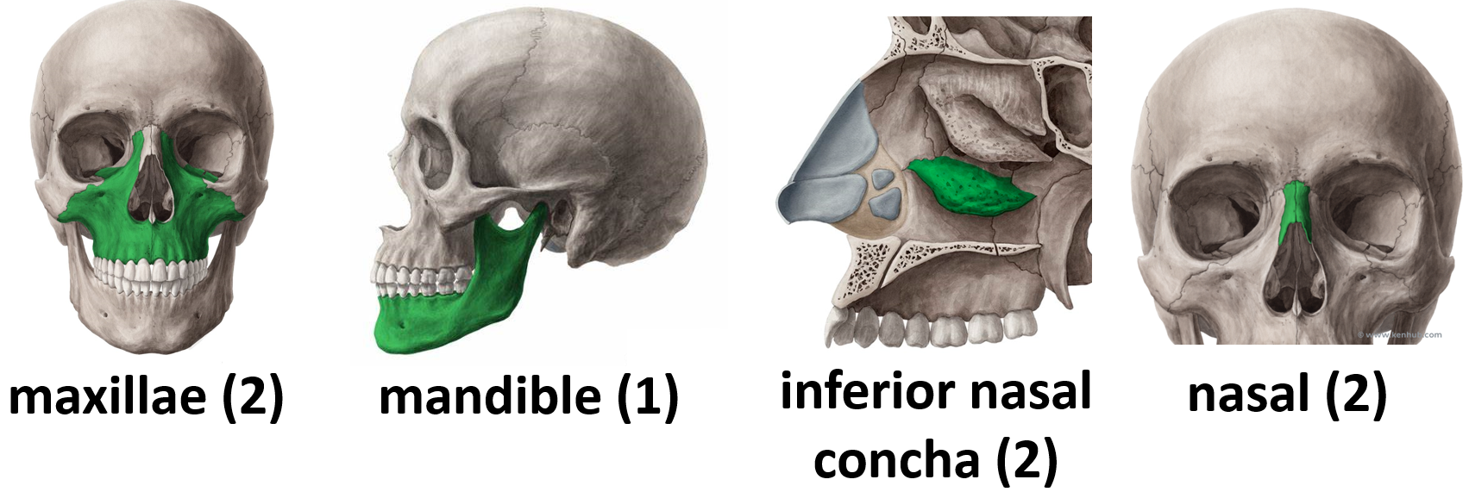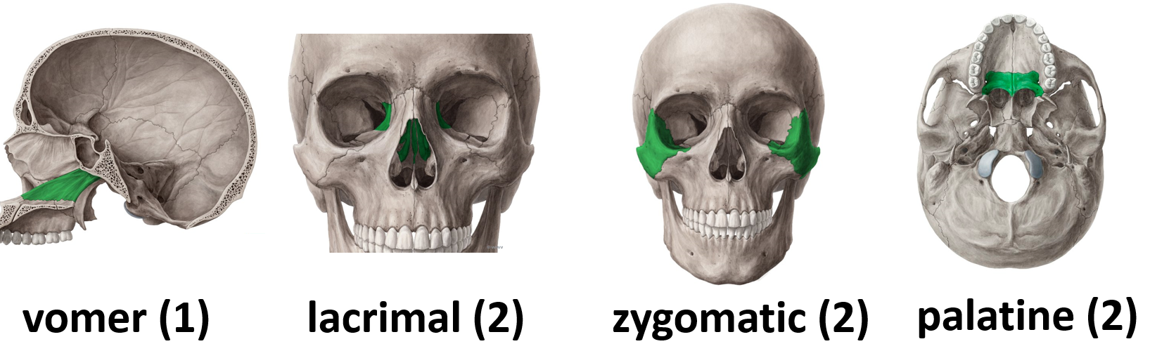**vomer (1):** forms part of the nasal septum   
**lacrimal (2):** houses the lacrimal sac, which forms tears   
**zygomatic (2):** form the prominence of the cheek   
**palatine (2):** form the posterior portion of the hard palate, part of the nasal cavity, and a small portion of the orbits

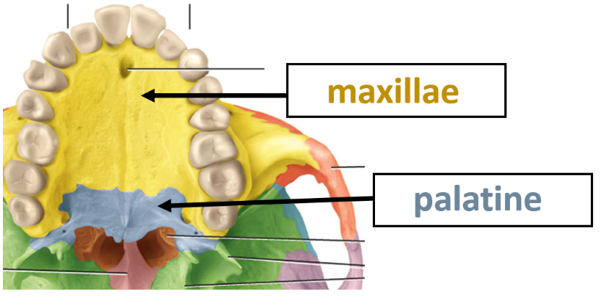*—* **special structures:** [1] hard palate [2] nasal septum

**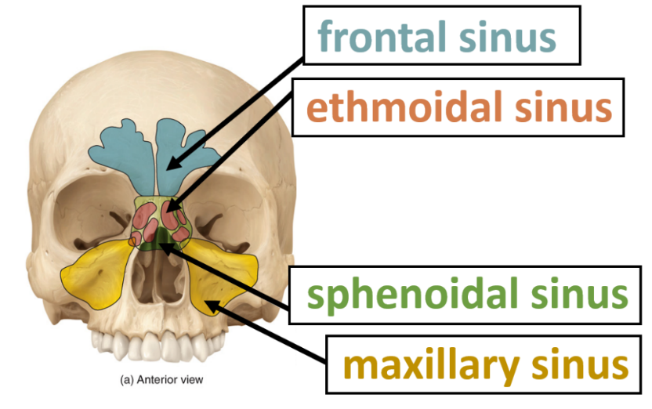***—* **paranasal sinuses:** cavities within certain bones near the nasal cavity  
🡪 lined with mucus membranes  
 that are continuous with the lining   
of the nasal cavity  
🡪 sinuses increase the surface  
 area of the nasal mucosa, thus   
increasing the production of mucus   
to help moisten and cleanse   
inhaled air  
🡪 small or nearly absent at birth,   
allow the skull to increase in size   
without a change in the mass of the  
bone

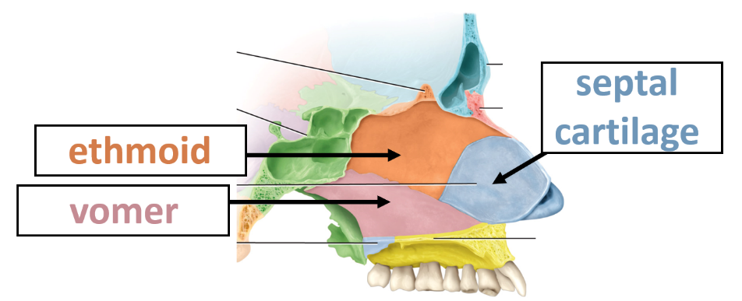

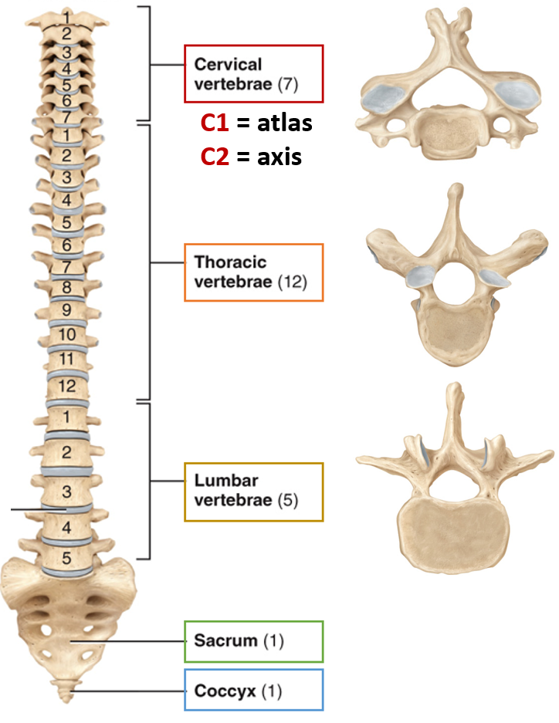*—* **hyoid bone:** supports the tongue  
🡪 doesn’t articulate with any other bone

*—* **vertebral column:** contains a series of bones   
called **vertebrae** organized into 5 regions  
[1] cervical [2] thoracic [3] lumbar [4] sacral [5] coccygeal

*—* **thoracic cage:** bony enclosure formed by the [1] sternum, [2] ribs and their [3] costal cartilages, and the bodies of the thoracic vertebrae  
[1] sternum: manubrium, body, xiphoid process   
[2] ribs: true ribs = 1-7, false ribs = 8-12

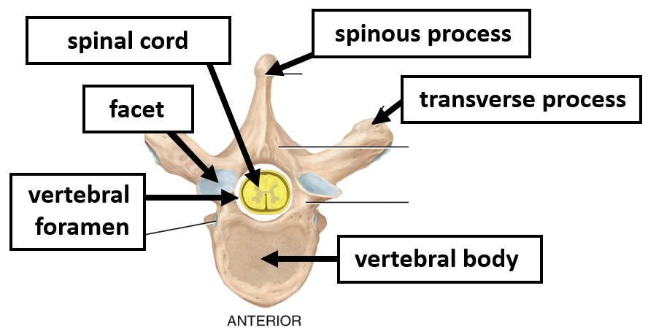

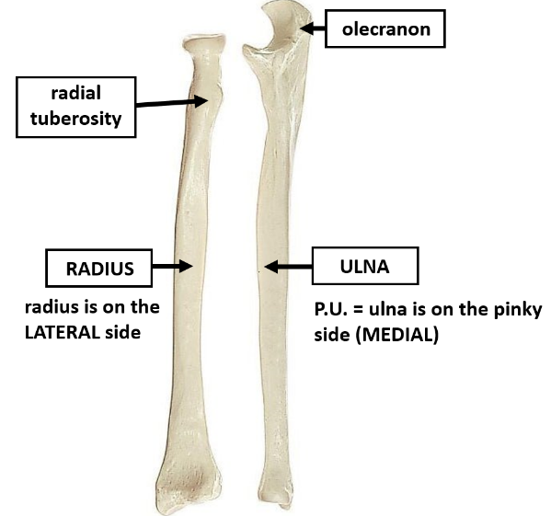**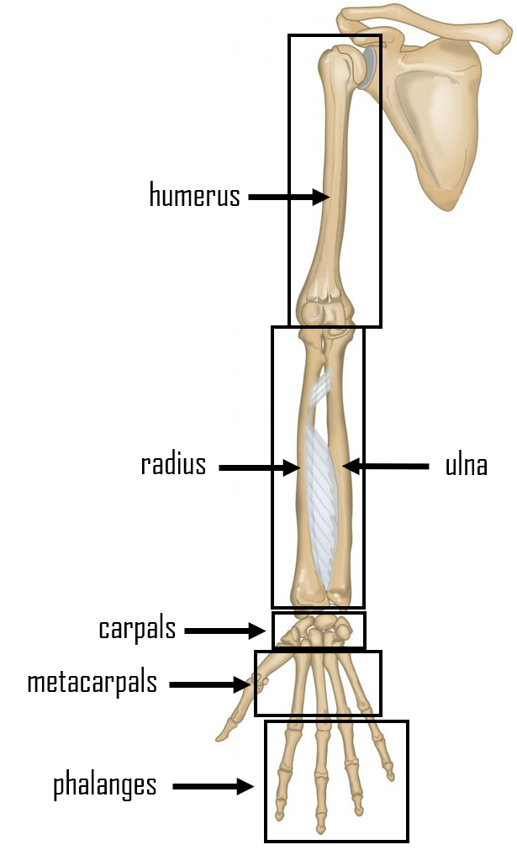CH 8: Appendicular Skeleton   
  
appendicular skeleton:** consists of bones of the upper and lower limbs + the bones forming the girdles, connecting limbs to the axial skeleton   
  
*—* **pectoral girdle:** clavicle + scapula  
  
*—* **scapula:**[1] acromion   
[2] glenoid cavity   
[3] coracoid process   
[4] spine  
  
*—* **humerus:**[1] greater and lesser tubercle   
[2] intertubercular sulcus   
[3] radial fossa   
[4] coronoid fossa   
[5] capitulum (lateral)   
[6] trochlea (medial)  
[7] olecranon fossa

*—* **ulna:** [1] olecranon = forms the prominence of the elbow

*—* **radius:**[1] radial tuberosity

*—* **carpal bones:**

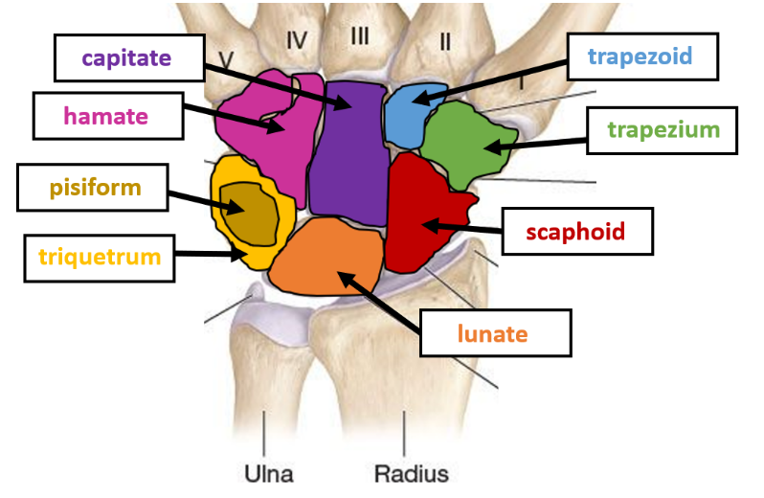[1] scaphoid   
[2] lunate   
[3] triquetrum   
[4] pisiform   
[5] trapezium   
[6] trapezoid   
[7] capitate   
[8] hamate

*—* **pelvic girdle:** 2 hips bones and the sacrum   
[1] pubic symphysis = cartilaginous joint that joints the hips anteriorly   
[2] sacroiliac joint = a synovial joint that connects the hip bones to the sacrum   
*—* **hip bone:**[1] ilium   
[2] ischium   
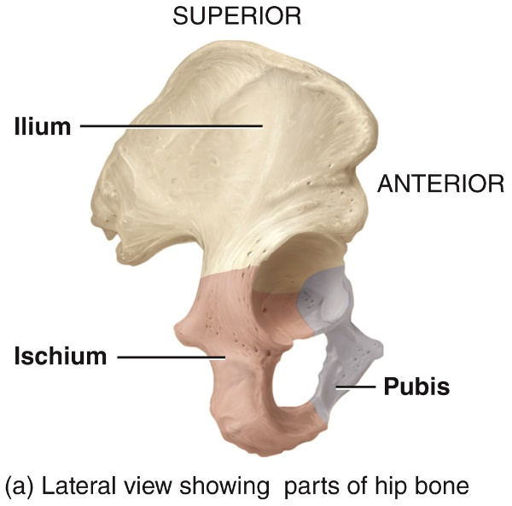[3] pubis   
[4] iliac crest   
[5] acetabulum   
[6] obturator foramen   
  
*—* **femur:**[1] head   
[2] greater trochanter   
[3] lesser trochanter   
[4] medial and lateral condyles

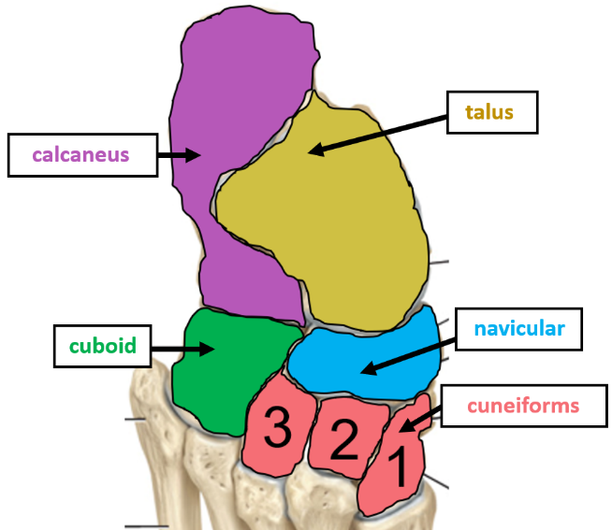*—* **tibia:**[1] tibial tuberosity   
[2] medial malleolus = forms the medial prominence of the “ankle”   
*—* **fibula:** la = LATERAL side[1] head   
[2] lateral malleolus = forms the lateral prominence of the “ankle”

*—* **tarsal bones:**

[1] calcaneus  
[2] cuboid  
[3] cuneiforms   
[4] navicular  
[5] talus

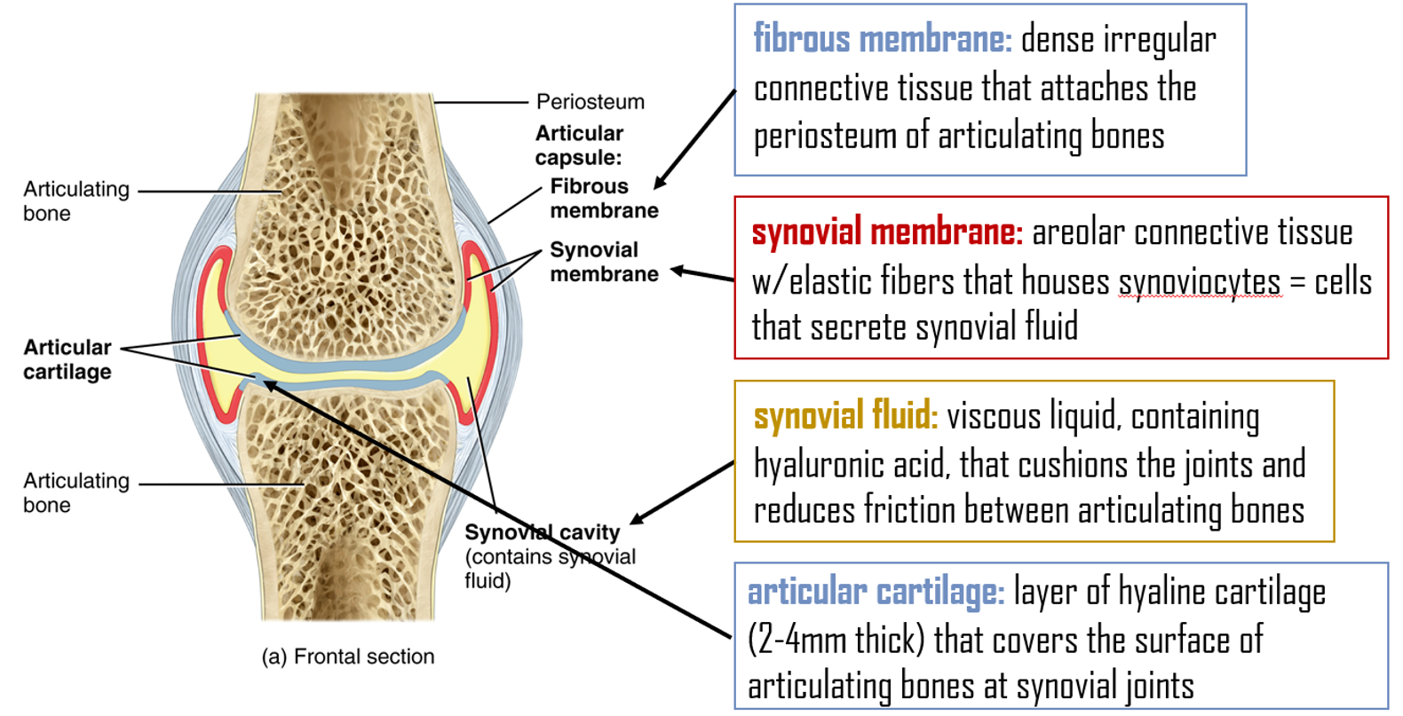**CH 9: Articulations***—* **fibrous joint:** held together by dense irregular connective tissue w/ collagen🡪 permits little to no movement and has no synovial cavity   
🡪 includes (1) sutures (2) syndesmoses (3) interosseous membranes *—* **cartilaginous joint:** held together by cartilage 🡪 permits little to no movement and has no synovial cavity   
🡪 (1) synchondroses = held together by hyaline cartilage (ex. epiphyseal growth plate)   
 (2) symphyses = ends of the articulating bones are covered with hyaline cartilage but a broad, flat disc of fibrocartilage connects the bones (ex. pubic symphysis) *—* **synovial joint:** bones united by dense irregular connective tissue that forms an articular capsule and the space between the bones includes a synovial cavity 🡪 all synovial joints are freely moveable (diarthroses)🡪 accessory structures: [1] accessory ligaments [2] articular discs   
 [3] labrum [4] bursae [5] tendon sheaths

**SELECTED VIDEOS:   
  
Ch 5: Integumentary System**[The Integumentary System, Part 1 - Skin Deep: Crash Course A&P #6 - YouTube](https://www.youtube.com/watch?v=Orumw-PyNjw)  
[The Integumentary System, Part 2 - Skin Deeper: Crash Course A&P #7 - YouTube](https://www.youtube.com/watch?v=EN-x-zXXVwQ)  
  
**Ch 6: Introduction to Bones**  
[The Skeletal System: Crash Course Anatomy & Physiology #19 - YouTube](https://www.youtube.com/watch?v=rDGqkMHPDqE)

**Ch. 7: Axial Skeleton**[The Vertebral Column](https://education.wiley.com/wpng/api/v1/content/resource/7b5ed4d0-4d45-4e76-b999-6a5dda9c62bf)

**Ch. 8: Appendicular Skeleton**[Pectoral (shoulder) girdle](https://education.wiley.com/wpng/api/v1/content/resource/d7f836d7-7d6c-4524-8a78-ad61570aa564)  
[The Pelvic Girdle](https://education.wiley.com/wpng/api/v1/content/resource/8c38f3be-541d-4386-bbad-101b38cce1f7)

**Ch. 9: Articulations**<https://www.youtube.com/watch?v=DLxYDoN634c&t=14s>